muni university server room
Risk Management Plan
Version 1.0A
03/08/2018

AGENCY: IT security Group 2
CONTACT:0783629494

VERSION HISTORY

Version # | Implemented  By | Revision  Date | Approved  By | Approval  Date | Reason
1.0 |  |  |  |  | Initial Risk Management Plan draft
1.1

TABLE OF CONTENTS

VERSION HISTORY 2
INTRODUCTION 1
1.1 INTRODUCTION Of The Risk Management Plan 1
1.2 Process 1
1.3 framing risk 1
1.3.1 Risk assumptions 2
1.3.2 Risk Constraints 3
1.3.3 Risk Tolerance 3
1.3.4 Priorities and Trade-Offs 3
1.4 assessing risk. 3
1.4.1 Threat and Vulnerability Identification 4
1.4.2 RISK DETERMINATION 4
1.5 responding to risk 4
1.5.1 RISK RESPONSE IDENTIFICATION 5
1.5.2 EVALUATION OF ALTERNATIVES 6
1.5.3 RISK RESPONSE DECISION 6
1.5.4 RISK RESPONSE IMPLEMENTATION 6
1.6 Monitoring risk 6
1.6.1 RISK MONITORING STRATEGY 7
1.6.2 RISK MONITORING 8
Tools And Practices 8
APPENDIX A: REFERENCES 10
APPENDIX B: KEY TERMS 11

INTRODUCTION

INTRODUCTION Of The Risk Management Plan
This risk management plan is based on National Institute of Standards and Technology (NIST) publication800-39 and National Information Security Framework (NISF) publication by National Information Technology Authority (NITA).
According to (Locke & Gallagher, 2011) Risk is measure of the extent to which an entity is threatened by a potential circumstance or event, and typically a function of the adverse impacts that would arise if the circumstance or event occurs; and the likelihood of occurrence.
However NIST publication800-39 focusses on managing information security risk; which it defines as the risk associated with the operation and use of information systems that support the missions and business functions of their organizations.
This Risk Management Plan defines the four steps prescribed by NIST: framing, assessment, responding to, and monitoring risks; including the tasks associated with them. The Risk Management Plan is created by the group two team and will be monitored and updated throughout the lifecycle of critical infrastructure of the muni university server room.

Process
The senior systems administrator with the server room team and the university governance board will ensure that risks are actively framed, assessed, responded to and monitored throughout the lifecycle of critical infrastructure of the muni university server room. The process of framing, assessing, responding to and monitoring risk will be executed in accordance with the NIST publication 800-39. These steps are further discussed in the sections below.

framing risk
According to (Locke & Gallagher, 2011), Risk framing is the set of assumptions, constraints, risk tolerances, and priorities/trade-offs that shape an organization’s approach for managing risk.
Risk framing will be the responsibility of the system administrator in consultation with the board of governance and they will be expected to carry out the tasks below.
In this document the system administrator and the board of governance will be termed as senior leadership.
The framing step will produce a set of organizational policies, procedures, standards, guidance, and resources covering the following topics;
- Scope of the Muni university server room risk management process (e.g., entities covered; mission/business functions affected; how risk management activities are applied within the risk management tiers).
- Risk assessment guidance including, for example, the characterization of threat sources, sources of threat information, representative threat events, when to consider and how to evaluate threats, sources of vulnerability information, risk assessment methodologies to be used, and risk assumptions.
- Risk response guidance including, for example, risk tolerances, risk response concepts to be employed, opportunity costs, trade-offs, consequences of responses, hierarchy of authorities, and priorities.
- Risk monitoring guidance, including, for example, guidance on analysis of monitored risk factors to determine changes in risk, and monitoring frequency, methods, and reporting;
- Risk constraints on executing risk management activities.
- Muni university’s server room priorities and trade-offs.
It is important to note that these outputs serve as inputs to the risk assessment, risk response, and risk monitoring steps.

Risk assumptions
The senior leadership will identify assumptions that affect how risk is assessed, responded to and monitored within the muni university server room.

Threat source
According to (Locke & Gallagher, 2011), Threat sources cause events having undesirable consequences or adverse impacts on organizational operations and assets, individuals, other organizations. In this case muni university server room.
Therefore the senior leadership will be expected to identify the hostile cyber/physical attacks; human errors of omission or commission; or natural and man-made disasters.

Vulnerability
Senior leadership will identify approaches used to characterize vulnerabilities, consistent with the characterization of threat sources and events which they would have identified above.
This will be categorized using the NIST’s categorization of exploitable weaknesses below;
(i) The hardware, software, or firmware components that compose organizational information systems or the security controls employed within or inherited by those systems.
(ii) Mission/business processes and enterprise architectures (including embedded information security architectures) implemented by muni university.
(iii) Organizational governance structures or processes.

Consequences and Impact
Senior leadership will provide guidance on how to assess impacts to organizational operations (i.e., mission, functions, image, and reputation), organizational assets, individuals, other organizations, and the Nation.
Additionally, senior leadership will make explicit any assumptions about the degree of consequences or impacts specific threat sources (by name or by type).

Likelihood
Senior leadership will have to treat the likelihood that a threat event will occur and the likelihood that, if it occurs, it will result in adverse effects as separate factors. Additionally the senior leadership will have to use qualitative risk assessment over quantitative risk assessment during risk assessment step, if there is a high degree of uncertainty. On qualitative assessment the following will be used to identify the likelihood of a threat event occurring
Worst case (i.e., attack will be successful unless strong, objective reasons to presume otherwise);
Best case (i.e., attack will not be successful unless specific, credible information to the contrary); or
Something in between best and worst cases.

Risk Constraints

Senior leadership will identify constraints on the conduct of risk assessment, risk response, and risk monitoring activities within the organization. Most important constraint to the execution of risk management process is financial limitation and therefore the senior leaders will have to find various ways in which it constraints risk management activities. Other constraints that the senior leadership will have to look into include legacy information systems, legal, regulatory, and/or contractual requirements.

Risk Tolerance
Senior leadership will identify the level of risk tolerance for the Muni University server room. NIST defines risk tolerance as the level of risk that organizations (function) are willing to accept in pursuit of strategic goals and objectives. Therefore the senior leadership of Muni University server room will need to define the level of tolerance for the following organizational and operational risks;
- Financial risk.
- Safety risk.
- Compliance risk.
- Reputation risk.

Priorities and Trade-Offs
The senior leadership will identify priorities and trade-offs considered by the Muni University server room in managing risk. The approaches devised by the senior leadership of Muni University server room for managing portfolios of risks should reflect Muni University’s culture, risk tolerance, as well as risk-related assumptions and constraints identified earlier.

assessing risk.
Risk assessment will identify, prioritize, and estimate risk to muni university server room operations (i.e., mission, functions, image, and reputation), server room assets, individuals, and other business functions like library, resulting from the operation and use of information systems.
Anyone from operation team or senior leadership should be able to carry out risk assessment tasks.
Inputs to the risk assessment step from the risk framing step include;
- Acceptable risk assessment methodologies;
- The breadth and depth of analysis employed during risk assessments;
- The level of granularity required for describing threats;
- Whether/how to assess external service providers; and
- Whether/how to aggregate risk assessment results from different organizational entities or mission/business functions to the organization as a whole.
The output of the risk assessment step will be a determination of risk to organizational operations (i.e., mission, functions, image, and reputation), organizational assets, individuals, other organizations, and the Nation.

Threat and Vulnerability Identification
The assessment team will identify threats to and vulnerabilities in organizational information systems and the environments in which the systems operate.
Threat identification will require an examination of threat sources and events. This will be accomplished by identifying threat capabilities, intentions, and targeting information from all available sources.
Vulnerabilities related to muni university server room governance, for example, inconsistent decisions about the relative priorities of mission/business processes, selection of incompatible implementations of security controls, as well as vulnerabilities related to external dependencies (e.g., electrical power, supply chain, telecommunications), will be effectively identified by senior leadership.

RISK DETERMINATION
In risk determination, the risk assessment team will determine the risk to the muni university server room operations and assets, individuals, and other functions if identified threats exploit identified vulnerabilities.
The team will determine risk by considering the likelihood that known threats exploit known vulnerabilities and the resulting consequences or adverse impacts if such exploitations occur.
The assessment team will as well use threat and vulnerability information together with likelihood and consequences/impact information to determine risk either qualitatively or quantitatively.

responding to risk
According to (Locke & Gallagher, 2011) Risk response identifies, evaluates, decides on, and implements appropriate courses of action to accept, avoid, mitigate, share, or transfer risk to organizational operations and assets, individuals, other organizations, and the Nation, resulting from the operation and use of information systems.
The inputs of the risk response stage will come from risk assessment and framing which include the following;
- identification of threat sources and threat events
- identification of vulnerabilities that are subject to exploitation;
- estimates of potential consequences and/or impact if threats exploit vulnerabilities;
- likelihood estimates that threats exploit vulnerabilities;
- a determination of risk to organizational operations (i.e., mission, functions, image, and reputation), organizational assets, individuals, other organizations;
- risk response guidance from the organizational risk management strategy ;
- The general organizational directions and guidance on appropriate responses to risk.

The output of this step is the implementation of the selected courses of action with consideration for:
- Individuals or organizational elements responsible for the selected risk response measures and specifications of effectiveness criteria.
- dependencies of each selected risk response measure on other risk response measures;
- dependencies of selected risk response measures on other factors (e.g., the implementation of other planned information technology measures);
- timeline for implementation of risk response measures;
- plans for monitoring the effectiveness of risk response measures;
- identification of risk monitoring triggers;
- Interim risk response measures selected for implementation, if appropriate.

RISK RESPONSE IDENTIFICATION
The senior system administrator with the operations team will identify alternative courses of action to respond to risk determined during the risk assessment.
This alternative courses will be based on the following strategies; risk acceptance, risk avoidance; risk mitigation, risk sharing; risk transfer, or a combination of the above as further explained below.

RISK ACCEPTANCE
According to NIST, Risk acceptance is the appropriate risk response when the identified risk is within the organizational risk tolerance.
Therefore muni university server room management will accept risk deemed to be low, moderate, or high depending on particular situations or conditions. This conditions could include the likelihood and the frequency of occurrence of the risk and compelling business mission or needs.

RISK AVOIDANCE.
According to NIST, Risk avoidance may be the appropriate risk response when the identified risk exceeds the organizational risk tolerance.
Muni university server room may conduct some types of activities or employ some types of technologies that result in risk that is unacceptable. In such scenario, risk avoidance will involve taking specific actions to eradicate the activities or technologies that are the basis for such risk.

RISK MITIGATION
According to NIST, Risk mitigation, or risk reduction, is the appropriate risk response for that portion of risk that cannot be accepted, avoided, shared, or transferred.
Example of potential risk that may require mitigation may be access of the network using mobile devices by the staff and the students.

RISK SHARING ORTRANSFER
According to NIST, Risk sharing or risk transfer is the appropriate risk response when organizations desire and have the means to shift risk liability and responsibility to other organizations.
For instance some of risks like fire outbreak may be insured against.

EVALUATION OF ALTERNATIVES
After coming up with the alternative courses of action, the operations team will evaluate the courses of action for responding to risk.
The evaluation of alternative courses of action may include:
- the expected effectiveness in achieving desired risk response (and how effectiveness is measured and monitored);
- Anticipated feasibility of implementation, including, for example, mission/business impact, and political, legal, social, financial, technical, and economic considerations.

RISK RESPONSE DECISION
At this level the decision on the appropriate course of action for responding to risk is made, and this may include some form of prioritization.

RISK RESPONSE IMPLEMENTATION
At this stage the actual implementation of the selected course of action is done.

Monitoring risk
Risk monitoring will provide muni university server room with the means to:
- verify compliance;
- determine the ongoing effectiveness of risk response measures; and
- Identify risk-impacting changes to organizational information systems and environments of operation.
The inputs to this stage include implementation strategies for selected courses of action for risk responses and the actual implementation of selected courses of action.

The output from the risk monitoring step is the information generated by:
- Verifying that required risk response measures are implemented and that information security requirements derived from and traceable to organizational missions/business functions, federal legislation, directives, regulations, policies, and standards/guidelines, are satisfied;
- Determining the ongoing effectiveness of risk response measures; and
- Identifying changes to organizational information systems and environments of operation.

RISK MONITORING STRATEGY

At this level risk monitoring strategy for muni University server room that includes the purpose, type, and frequency of monitoring activities will be developed by muni university senior administrator and the operation team.

MONITORING COMPLIANCE

According to (Locke & Gallagher, 2011) Compliance monitoring is employed to ensure that organizations are implementing needed risk response measures. Therefore the monitoring compliance will includes insuring that the risk response measures selected and implement by muni university server room are in accordance NITA standards and other compliance laws

MONITORING EFFECTIVENESS

According to (Locke & Gallagher, 2011) ; Effectiveness monitoring is employed by organizations to determine if implemented risk response measures have actually been effective in reducing identified risk to the desired level. In case a given course of action is raised to have not been effective the risk management team will have to revisit the risk response step to find out the courses.

MONITORING CHANGES

Change monitoring will involve two aspects;

Monitoring changes to information system

Monitoring changes in environment of operation.
Changes to information system that will need to be monitored by the system administrator and the operation team include hardware, software and firm ware changes. These are likely to introduce new risks or change existing risks. Changes to in environments of operation will include but not limited to missions/business functions, threats, vulnerabilities, mission/business processes, facilities, policies, legislation, and technologies.

FREQUENCY OF MONITORING

The frequency of risk monitoring (whether automated or manual) will drive be driven by Muni UNIVERSITY server room business function however the following factors should be considered;
- The anticipated frequency of changes in Muni University server room information systems and operating environments.
- The potential impact of risk if not properly addressed through appropriate response measures; and

The degree to which the threat space is changing.

RISK MONITORING

Tools And Practices
TOOLS:
Questionnaires
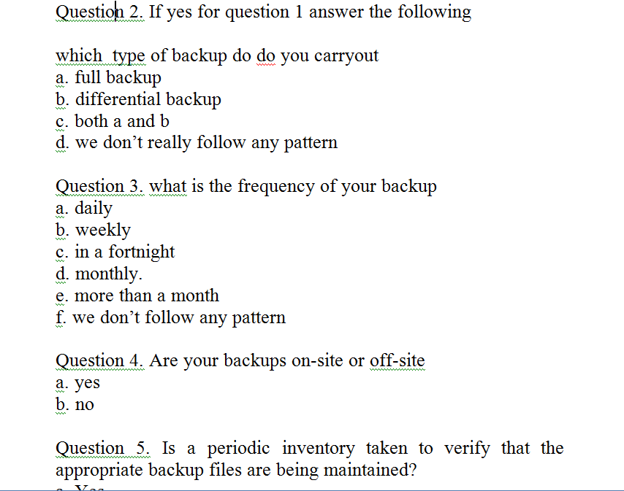
Figure 1Sample of questionnaire to be used

Observation

risk management plan approval
The undersigned acknowledge they have reviewed the Risk Management Plan for the muni university server room project. Changes to this Risk Management Plan will be coordinated with and approved by the undersigned or their designated representatives.

Signature: | adriko debo joel | Date: | 06/04/2018
Print Name: | ADRIKO DEBO JOEL
Title: | MR
Role: | TEAM LEADER

Signature: | adaku john | Date: | 06/04/2018
Print Name: | ADAKU JOHN
Title: | MR.
Role: | COORDINATOR

Signature: | Ore denish | Date: | 06/04/2018
Print Name: | OREE DENISH
Title: | MR.
Role: | SECRETARY

Signature: | Chandiru rose mary | Date: | 06/04/2018
Print Name: | CHANDIRU ROSE MARY
Title: | MISS
Role: | ACTIVE TEAM MEMBER

Signature: | ceaser enzama | Date: | 06/04/2018
Print Name: | CEASER ENZAMA
Title: | MR.
Role: | ACTIVE TEAM MEMBER

Signature: | Ocatre frank | Date: | 06/04/2018
Print Name: | OCATRE FRANK
Title: | MR.
Role: | ACTIVE TEAM MEMBER

Signature: | Enzebo emmanuel | Date: | 06/04/2018
Print Name: | ENZEBO EMMANUEL
Title: | MR.
Role: | ACTIVE TEAM MEMBER

APPENDIX A: REFERENCES
Information Security2011GaithersburgNational Institute of Standards and Technology
NITA2014KampalaNATIONAL INFORMATION SECURITY FRAMEWORK (NISF)

APPENDIX B: KEY TERMS

The following table provides definitions for terms relevant to the Risk Management Plan.
Term | Definition
NITA | National Information Security Policy  The policy outlines the mandatory minimum security controls that all public and private sector organisations that use, own and/or operate protected computers, handle official communications and personal data must apply to reduce their vulnerability to cyber threats. The use of the security measures mandated by this policy would increase the capacity of organisations to endure and recover from cyber attacks.
NIST | National Institute of Standards and Technology  The publication that contains standards and guidelines on risk management process. NIST800-39 categorizes risk management process into four steps: framing, assessment, responding and monitoring

